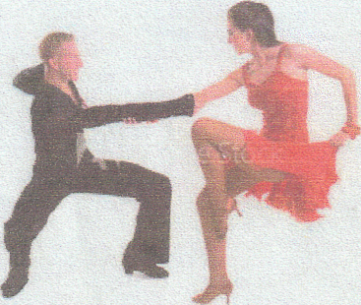
COMFORT INN
JANUARY OLDIES DANCE
Hits of the 50’s, 60’s and 70’s
SAT. January13, 2018 8 P.M. Includes 1 Free Drink - $10 per/Person

MUSIC BY D.J.RON

Rt. 28 Bar & Grill, Comfort inn, RIDC Park

Limited Food Available.

